Post Windows CL config validate it following test.

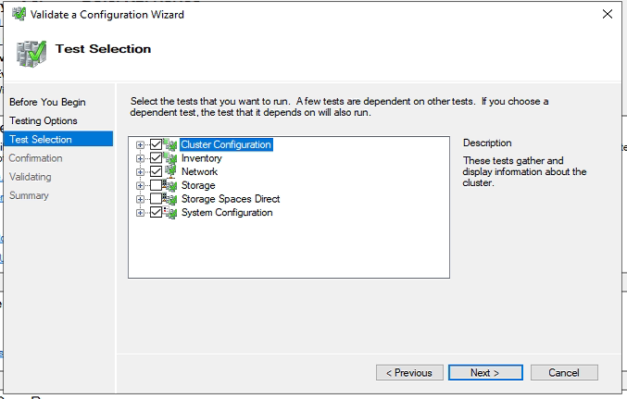

Validate reports and solve if any.

Enable AlwaysOn Availability Groups for SQL instance on all nodes involved in Cluster

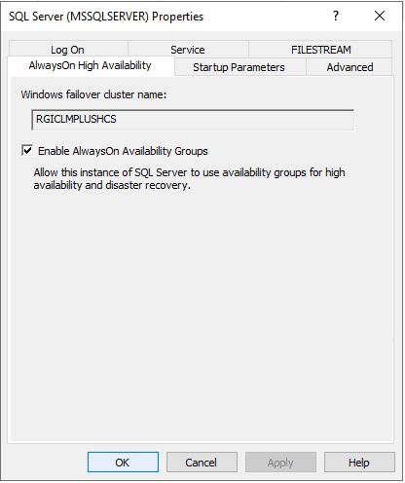

Create Aliases on all nodes for servers involved in Cluster

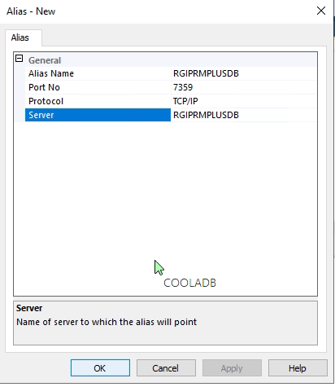

Create TestAG database

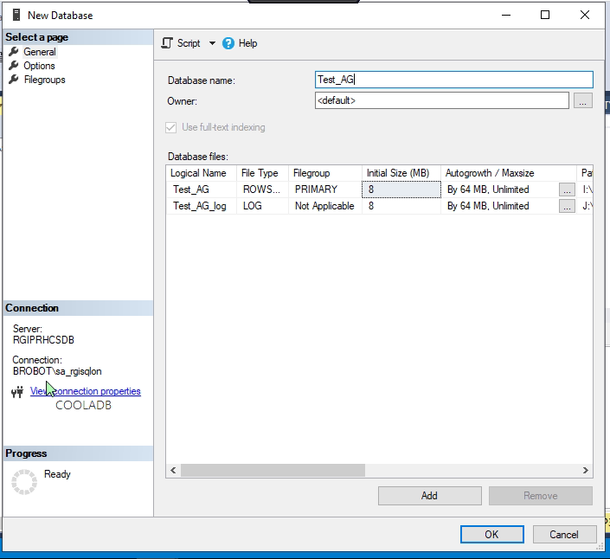

Take a full backup 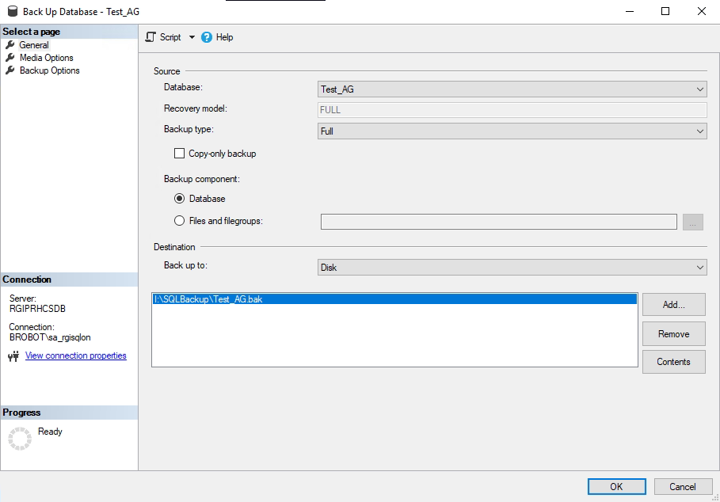

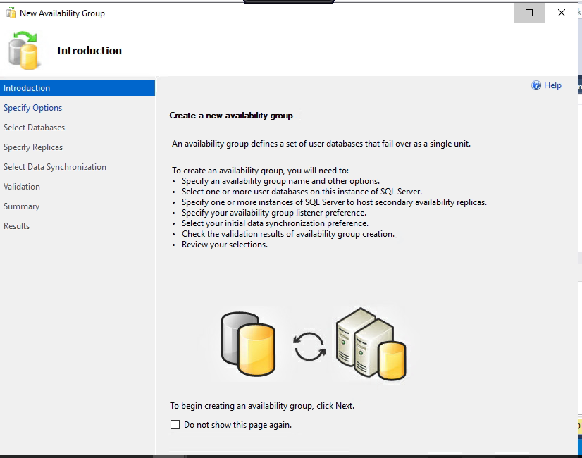

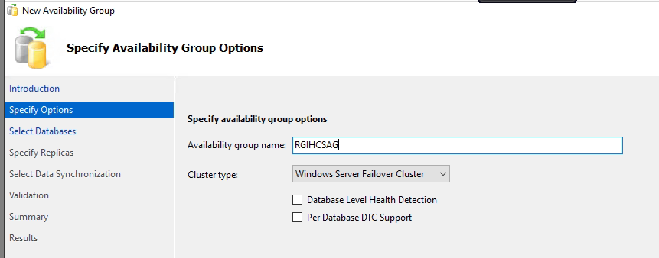

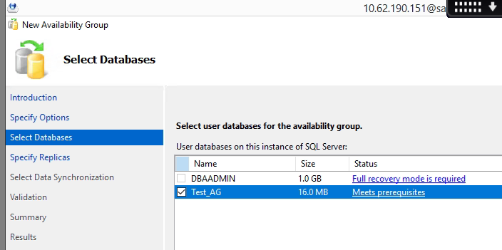

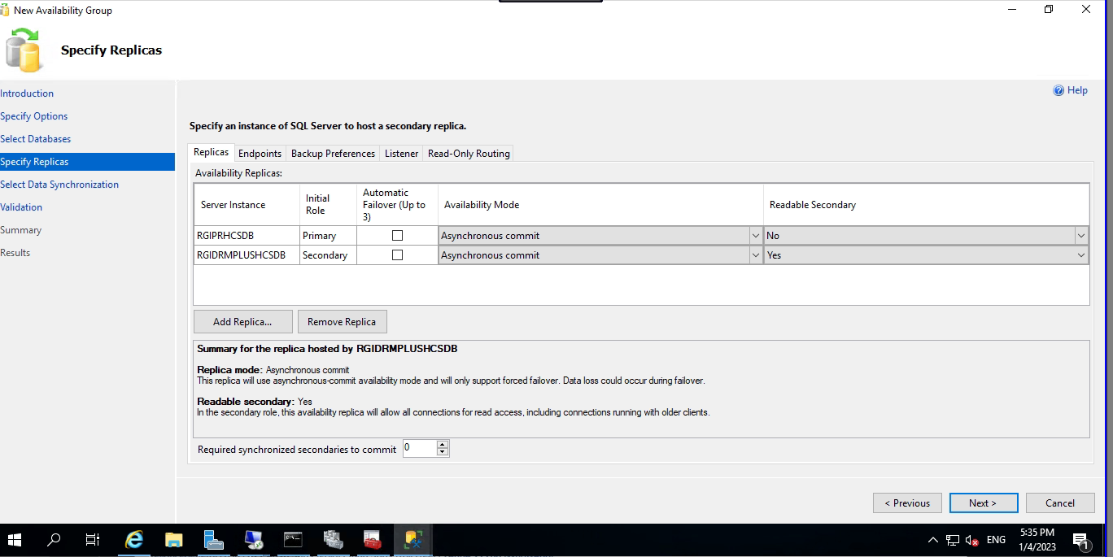

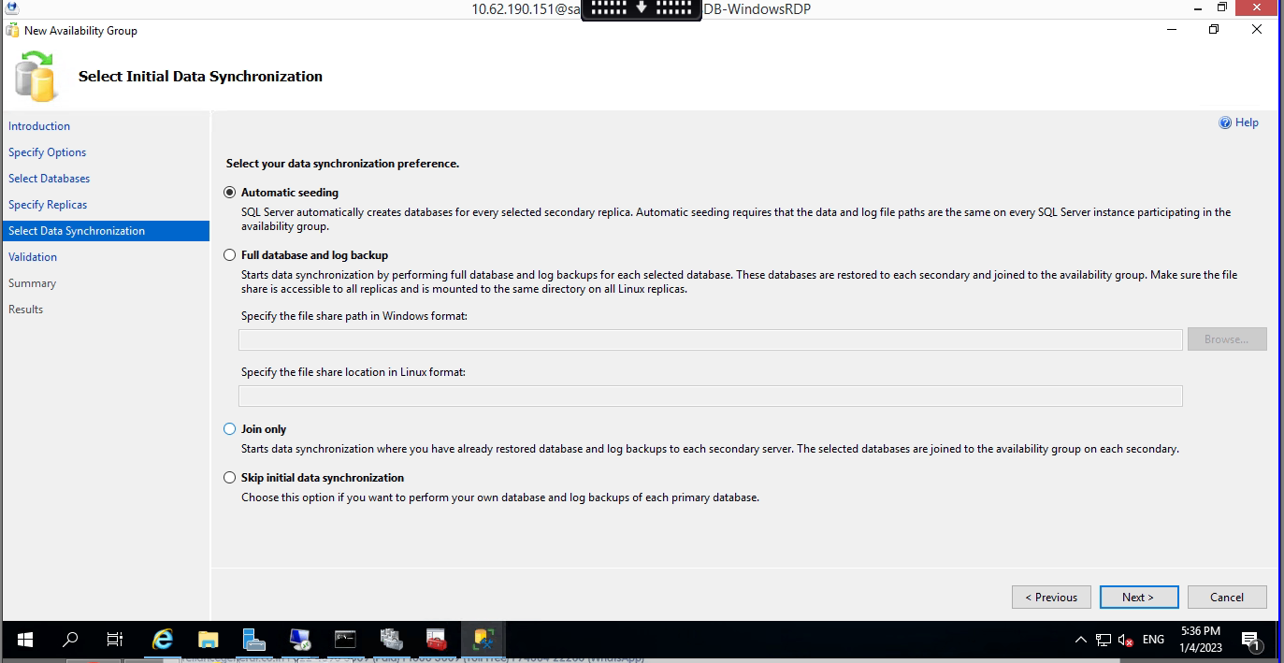

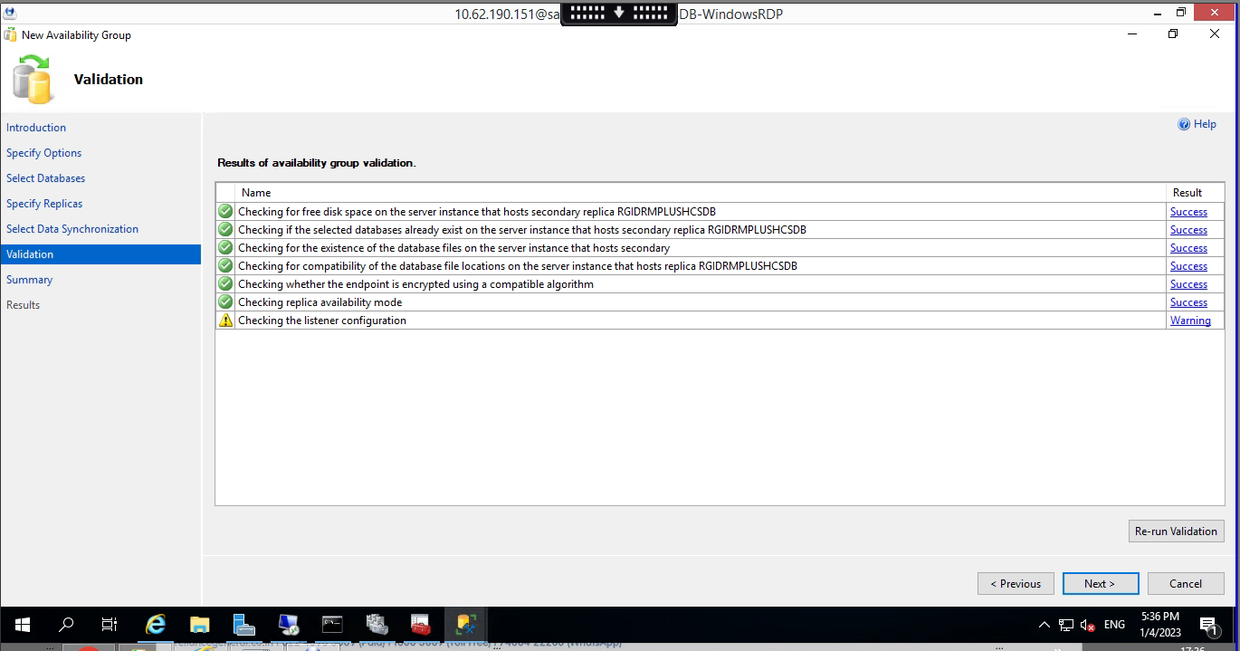

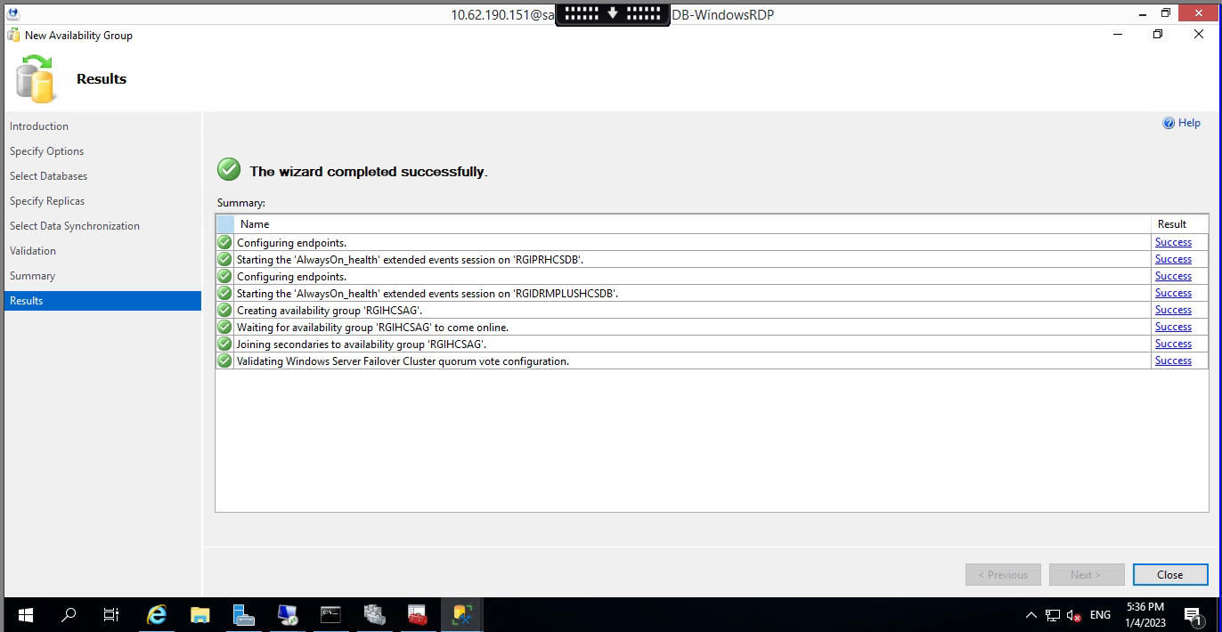

Now Create Listner

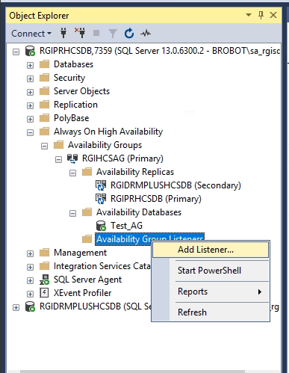

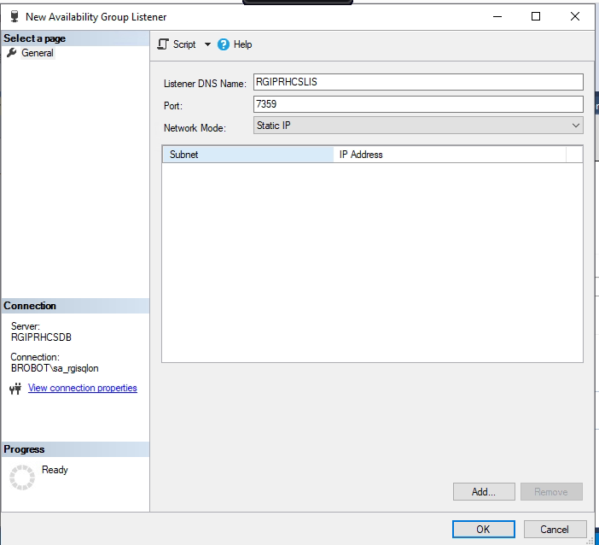

As we have two diff segments , we need to create listner with two segment ip.

for prod

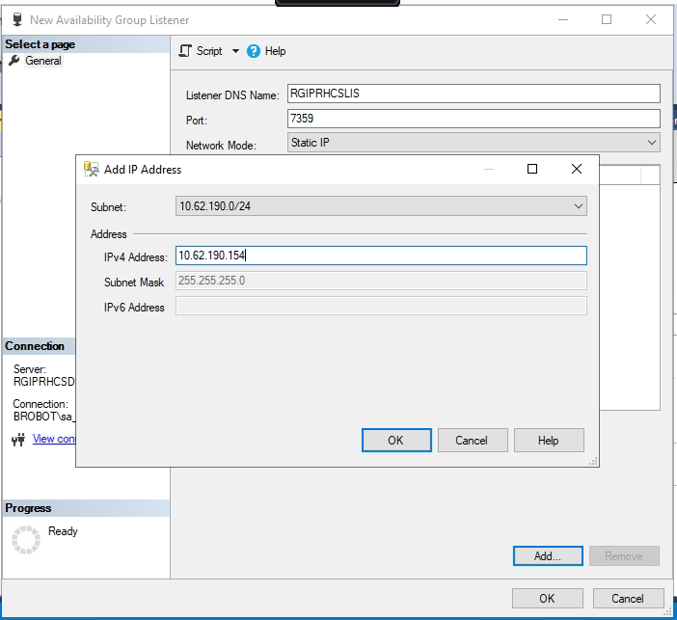

for DR

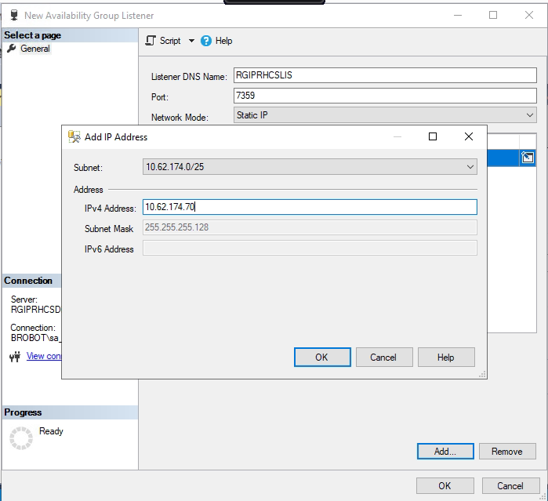

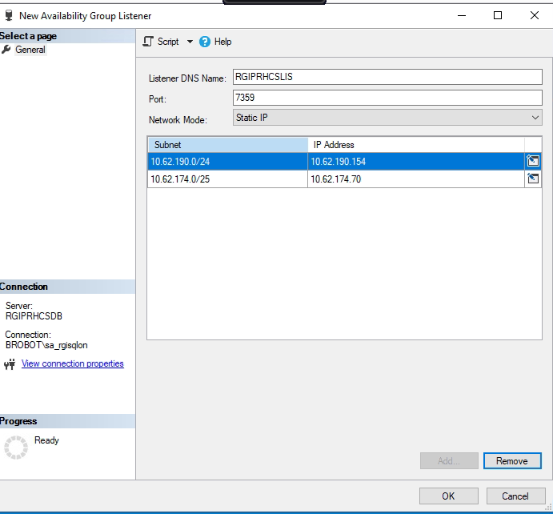

[SQL Server Failover Cluster Behind Azure Internal Load Balancer (mssqltips.com)](https://www.mssqltips.com/sqlservertip/6658/sql-server-failover-cluster-behind-azure-internal-load-balancer/)

$ClusterNetworkName = "Cluster Network 1"

$IPResourceName = "SQL IP Address 1"

$ILBIP = "10.0.0.0"  → should be the load balancer IP; same as sql role cluster IP

[int]$ProbePort = 59999 → the health probe port we used in the load balancer health probe set up

Import-Module FailoverClusters

Get-ClusterResource $IPResourceName | Set-ClusterParameter -Multiple @{"Address"="$ILBIP";"ProbePort"=$ProbePort;"SubnetMask"="255.255.255.255";"Network"="$ClusterNetworkName";"EnableDhcp"=0}

Get-ClusterResource $IPResourceName | Get-ClusterParameter

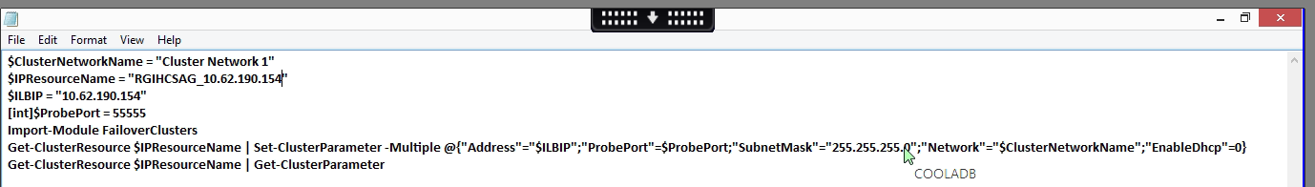

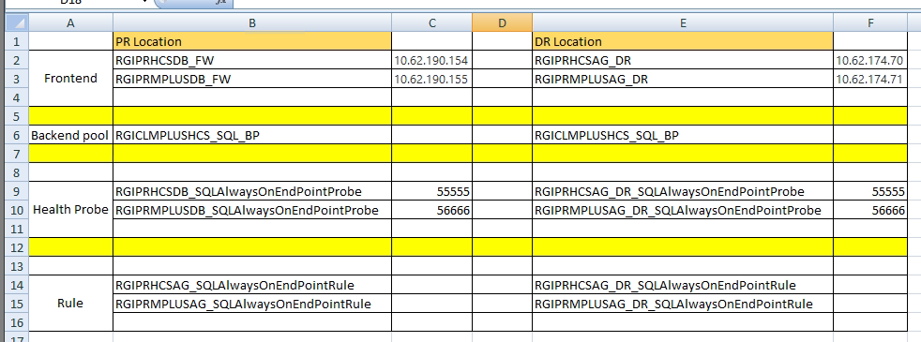

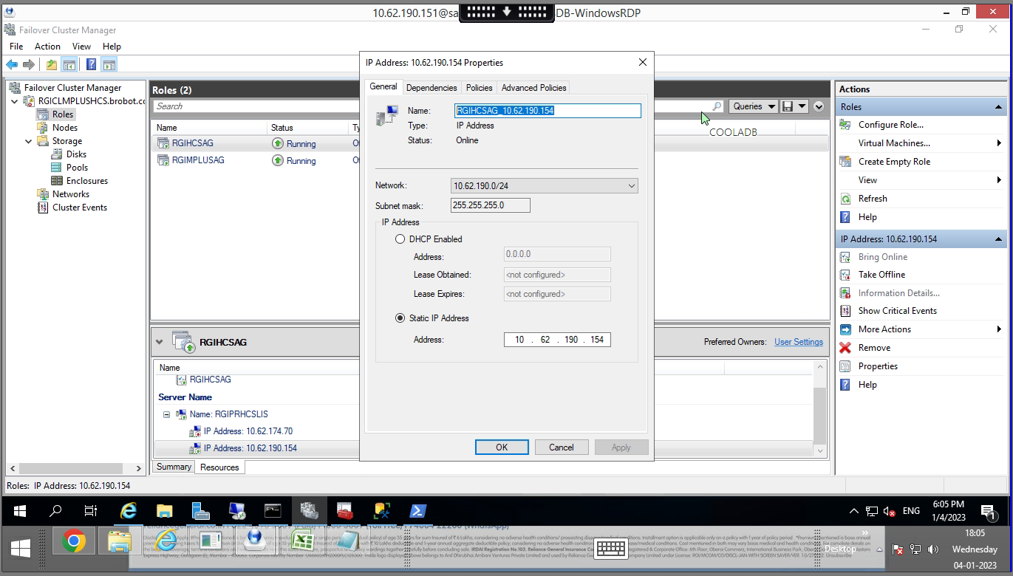

Run Powershell as admin

Primary

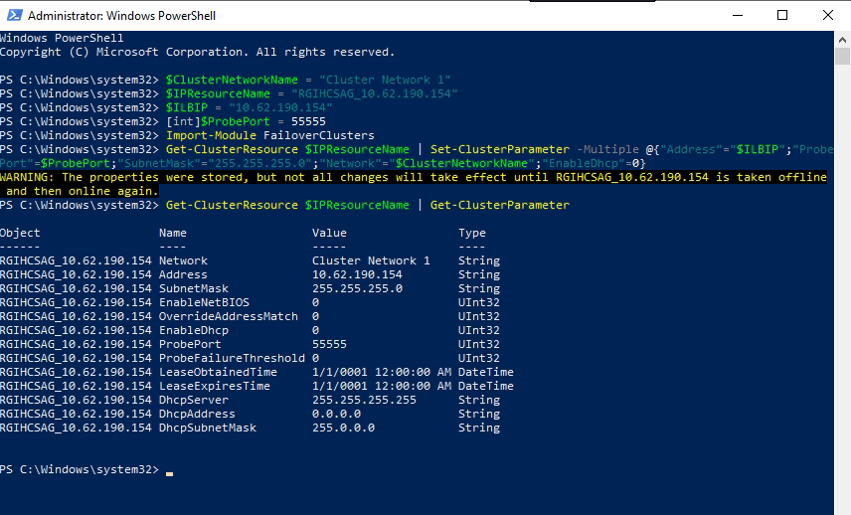

Secondary DR

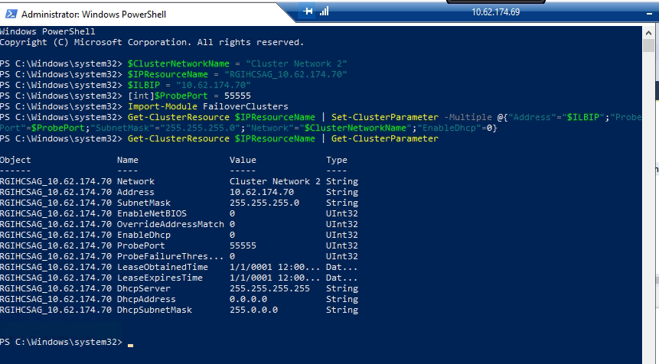

Make offline online listner ip once